Design of IOT Architecture for Battery Charging Management Technology

Dr. Sujith kalluri Ph.D _ ECE
SRM University, Andhra Pradesh, India
sujith.k@srmap.edu.in

Mr. Jagadeeswara Chandra bose. K M.Tech _ ECE
SRM University, Andhra Pradesh, India
Jagadeeswara_kamarajugadda@srmap.edu.in

Abstract - The research investigates the creation of an IoT architecture tailored for battery charging management, addressing the future demand for electric vehicle (EV) charging infrastructure. With the rise in EV adoption, the integration of renewable energy sources, including solar power and energy storage systems (ESS), alongside grid power, is vital for establishing sustainable charging solutions. The proposed architecture features five distinct layers: User Interface Application Layer, Cloud Server and Data Storage, Communication Layer, Microcontroller and Data Acquisition Layer, and Sensor Layer. This innovative system utilizes real-time data monitoring and predictive analytics to optimize power demand, enhance battery management, and boost operational efficiency in EV charging operations. Initial simulations suggest a remarkable potential for reducing operational costs by improved resource utilization. The study identifies significant gaps in the current landscape, such as the absence of uniform standards for EV charging stations and a lack of comprehensive research on the economic viability of grid -to-vehicle technology. The methodology centers on designing a layered architecture that supports remote monitoring of charging data while integrating multiple energy sources at the Point of Common Coupling (PCC). Future developments will aim to refine this architecture further to enhance energy management capabilities, ultimately contributing to a more sustainable transportation ecosystem.

Keywords: Solar, Energy Storage System (ESS), Grid, Point of Common Coupling (PCC), Fast Charging, Battery Swapping, Data Visualization, Cloud Integration.

- Introduction
The rapid growth of electric vehicles (EVs) has highlighted the critical need for an efficient and robust charging infrastructure. As the global shift towards sustainable transportation accelerates, the demand for innovative charging solutions has become increasing rapidly. This research focuses on developing an Internet of Things (IoT) architecture specifically designed for battery charging management, which integrates renewable energy sources such as solar power and energy storage systems (ESS) with grid power.

The proposed architecture comprises five layered components:
- Sensor Layer: The sensor layer is critical for gathering real-time data on various parameters such as charging status, energy levels, and environmental conditions. This information is essential for optimizing the charging process.
- Microcontroller and Data Acquisition Layer: This layer comprises microcontrollers that collect data from sensors deployed across the charging stations. It processes this data to monitor performance metrics and operational efficiency.
- Communication Layer: This layer facilitates seamless communication between different components of the architecture, ensuring reliable data transmission and integration among the IoT devices.
- Cloud Server and Data Storage: This layer is responsible for managing the data collected from various sensors and devices within the charging infrastructure. Its secure storage and processing of data, enabling remote access and analytics.
- User Interface Application Layer: This layer provides a user-friendly interface for end-users to monitor charging status, energy consumption, and operational metrics in real time. It enhances user engagement by allowing operators to make informed decisions based on accessible data.

This multi-layered approach facilitates real-time data monitoring and analytics, enabling optimized power demand management and enhanced operational efficiency in EV charging operations. Initial simulations suggest that this system achieved significant operational cost reductions up to 88.5% by optimizing resource utilization. Furthermore, the research addresses existing challenges in the EV charging landscape, including the lack of uniform standards for charging stations and limited studies on the economic viability of grid-to-vehicle technology. By designing a comprehensive architecture that allows for remote monitoring and integration of multiple energy sources at the Point of Common Coupling (PCC), the proposed designed system is shown in fig 1. This work aims to contribute to a more sustainable transportation ecosystem while also promoting the way for future advancements in energy management capabilities.
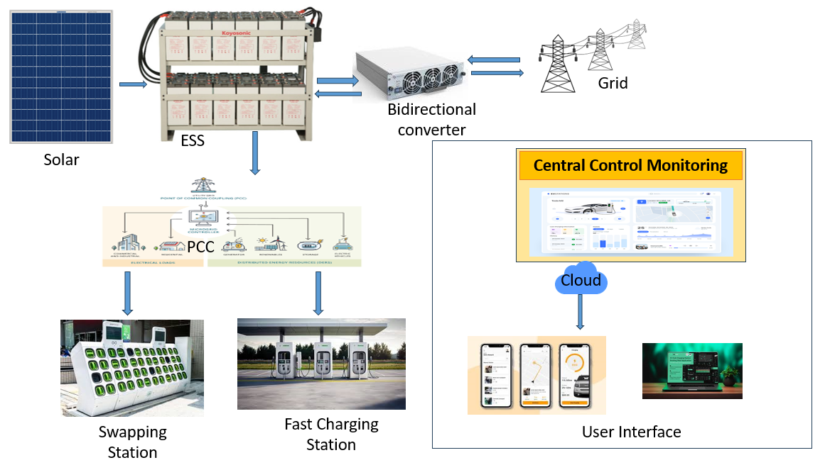
Fig 1: Integration of power sources and charging load with PCC

Both battery swapping and DC fast charging play vital roles in creating a comprehensive EV charging ecosystem. By integrating these technologies with IoT architecture, real-time data monitoring and predictive analytics can optimize energy management, enhance operational efficiency, and promote sustainable practices within the charging infrastructure. This multifaceted approach not only meets the current demands of EV users but also supports future advancements in smart city initiatives and renewable energy integration.

On the other hand, DC fast charging technology provides rapid charging capabilities that can replenish an EV's battery to 80% in approximately 30 minutes, depending on the vehicle and charger specifications. This technology is essential for long-distance travel and urban charging networks, as it addresses anxiety among consumers. DC fast chargers utilize high-voltage direct current to deliver power directly to the vehicle's battery, by passing the onboard charger and significantly reducing charging times. The strategic placement of DC fast charging stations along highways and in urban areas is crucial for supporting the growing EV market.

The rest of the paper is outlined as follows: Section 2 Literature survey; Methodology in detailed in section 3. While section 4 contains its solution methodology. MATLAB Simulation and results are discussed in section 5. Finally, the paper is concluded in section 6.

- Literature Survey

- Methodology

The architecture integrates three sources of power: solar energy, energy storage systems (ESS), and grid power, connected at the Point of Common Coupling. If solar energy is present, the ESS charges simultaneously as it powers the load. If the ESS is more than 80% charged, the excess power flows back to the grid using a DC to AC and bidirectional converter. In return, when there is no availability of sunlight, the ESS discharges to supply power to the load while disconnecting from the grid. When the ESS drops to 20% charge and sunlight is not available, it will then start drawing power from the grid. The ESS can recharge if there is an ideal load condition. The loads in this system include a battery swapping station with 30 batteries and four DC fast charging stations. All unit parameters are monitored through sensors, and collected data is transmitted to a central monitoring station as well as to a cloud-based user interface.
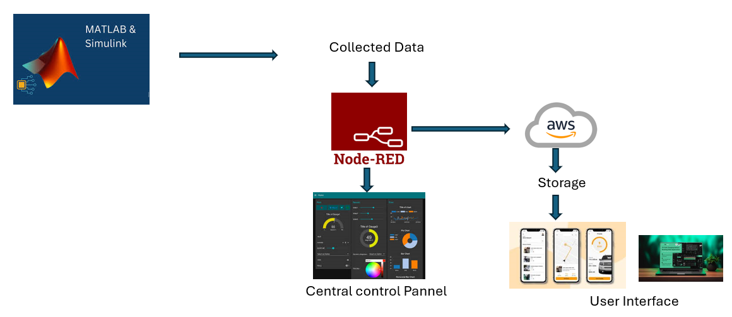
Fig 2: Flow of Methodology
The methodology also incorporates predictive analytics to optimize power demand management, allowing for dynamic adjustments based on real-time data. Simulations using MATLAB and Node-RED validate the architecture's effectiveness in managing energy resources efficiently. Furthermore, the implementation framework outlines how this IoT architecture can be deployed in real-world scenarios, promoting scalability and adaptability in response to growing EV adoption. The flow of the project shows in fig 2. Ultimately, this comprehensive methodology aims to enhance operational efficiency while contributing to a more sustainable transportation ecosystem.

- Proposed Design and Architecture.
- IOT Architecture
The five-layer architecture proposed for the IoT framework in battery charging management technology is designed to enhance the efficiency and effectiveness of electric vehicle (EV) charging infrastructure. Each layer serves a specific function that collectively contributes to the overall system's performance.
The proposed IOT Architecture show in fig 3.
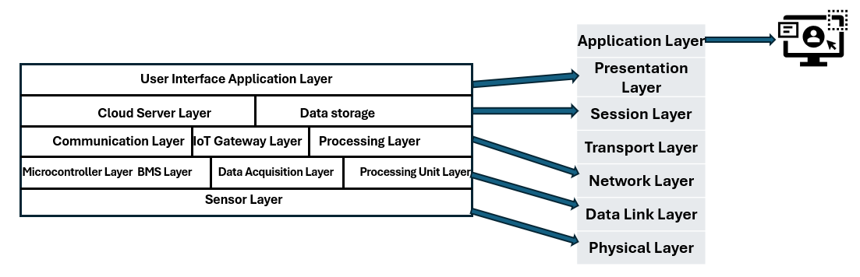
Fig 3: Five-layer IOT architecture
- Sensor Layer: The sensor layer is critical for gathering real-time data on various parameters such as charging status, energy levels, and environmental conditions. This information is essential for optimizing the charging process and informing other layers about operational dynamics.
- Microcontroller and Data Acquisition Layer: Comprising microcontrollers that collect data from sensors deployed across the charging stations, this layer processes information to monitor performance metrics and operational efficiency. It acts as the backbone of data collection, ensuring accurate real-time monitoring.
- Communication Layer: This layer facilitates seamless communication between different components of the architecture, ensuring reliable data transmission among IoT devices. It plays a vital role in maintaining connectivity and ensuring that all parts of the system can interact efficiently.
- Cloud Server and Data Storage Layer: This layer is responsible for managing the data collected from various sensors and devices within the charging infrastructure. It ensures secure storage and processing of data, enabling remote access and analytics that are crucial for effective decision-making.
- User Interface Application Layer: This top layer provides an intuitive interface for users, allowing them to monitor charging status, energy consumption, and operational metrics in real time. It enhances user engagement by enabling operators to make informed decisions based on accessible data.
Together, these layers create a robust IoT architecture that leverages real-time data monitoring and analytics to optimize power demand management, enhance battery performance, and improve overall operational efficiency in EV charging operations. By integrating renewable energy sources such as solar power with energy storage systems (ESS) and grid power at the Point of Common Coupling (PCC), the architecture not only supports sustainable practices but also addresses current challenges in EV charging infrastructure.
- Power Flow
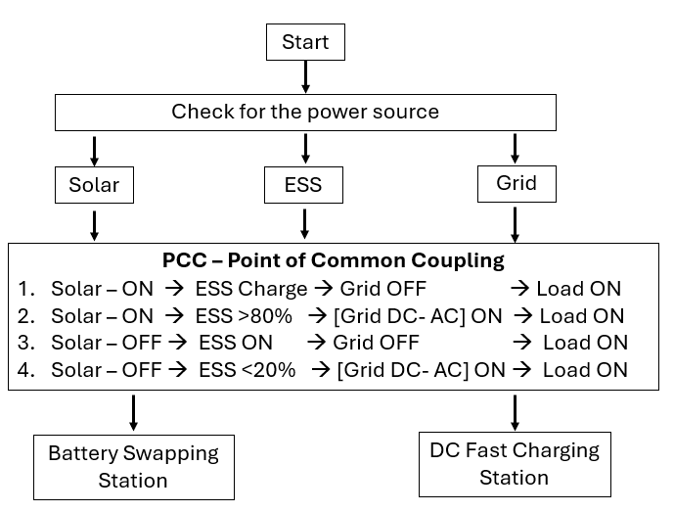
Fig 4: outlines the logic for managing the charging of batteries
This flowchart outlines the logic for managing the charging of batteries in a system shows in fig 4 that integrates multiple power sources: solar, energy storage systems (ESS), and the grid. The system aims to optimize battery charging by prioritizing renewable energy sources and utilizing the grid when necessary.
Start: The process begins with a check for available power sources. Solar: If solar power is available, it is used to charge the battery. ESS: If the ESS is available and not fully charged, it is charged.
Grid: If neither solar nor ESS is available, the grid is used for charging.
Charging Scenarios: Solar ON, ESS Charge: If solar power is available and the ESS is not fully charged, solar power is used to charge the ESS, and the grid is turned off. Solar ON, ESS > 80%: If solar power is available and the ESS is more than 80% charged, solar power is used to power the load directly, and the grid is turned on to provide backup power. Solar OFF, ESS ON: If solar power is not available and the ESS has sufficient charge, the ESS is used to power the load. Solar OFF, ESS < 20%: If solar power is not available and the ESS is less than 20% charged, the grid is used to power the load.
- PCC Integration and Automation
This flowchart outlines the logic for integrating a Point of Common Coupling (PCC) with various power sources (solar, ESS, and grid) to optimize energy flow and manage battery charging shown in fig 5.
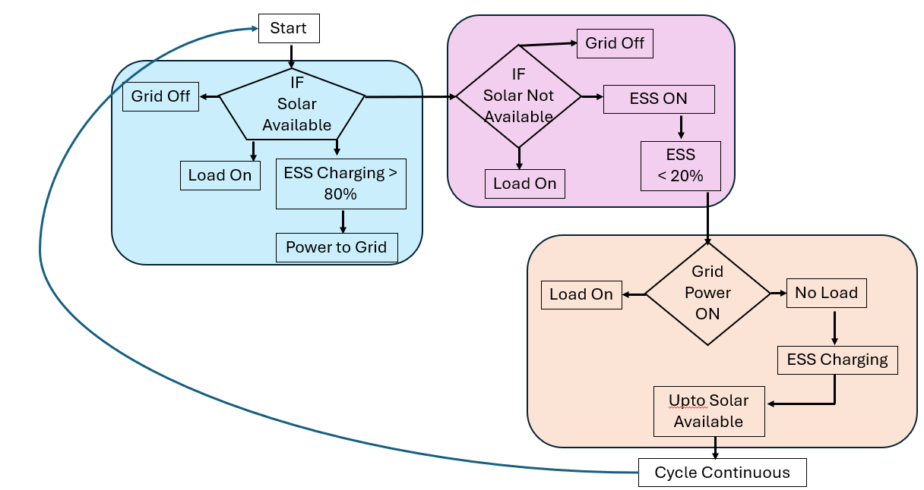
Fig 5: PCC Integration and Automation
Solar Available: If solar power is available, the ESS will start charging. Once the ESS reaches above 80% of charge, then solar power is fed back to the grid.
Solar not Available: If solar power is not available, the ESS is used to power the load, If the ESS is getting below 20%, then grid power is used to power the load.
Grid Power ON: If grid power is available, it is used to power the load. When the loads are in the ideal stage then the ESS will start recharging.
Cycle Continuous: The process continues in a loop, checking for solar availability and adjusting power flow accordingly.

- Algorithms
The proposed algorithms within the IoT architecture for battery charging management are essential for optimizing the charging operations of electric vehicles (EVs) while integrating renewable energy sources such as solar power and Energy Storage Systems (ESS) with grid electricity.
- The State of Charge (SOC) Calculation Algorithm plays a pivotal role by determining the current state of charge of the battery based on voltage readings and predefined thresholds, ensuring that the SOC remains within safe limits to prevent overcharging or deep discharging, which can adversely affect battery health.
- The Charging and Discharging Control Algorithm manages the charging and discharging processes based on the SOC; it prioritizes load operation when the SOC is above a certain threshold (e.g., 80%) and initiates charging when it falls below a specified level (e.g., 40%).
- The Maximum Power Point Tracking (MPPT) Algorithm optimizes the power output from solar panels by continuously adjusting the duty cycle based on real-time voltage and current measurements, ensuring maximum energy harvesting from solar resources under varying environmental conditions. The Data Monitoring and Predictive Analytics Algorithm collects real-time data from various sensors monitoring parameters such as voltage, current, temperature, and insulation resistance. This algorithm employs predictive analytics to forecast energy needs, allowing for proactive management of charging schedules and resource allocation.
- The Energy Source Management Algorithm determines the optimal use of available energy sources—solar, ESS, or grid power—based on real-time conditions. It prioritizes solar energy first, utilizes stored energy from ESS when solar generation is insufficient, and resorts to grid power only when necessary. Collectively, these algorithms enhance operational efficiency, improve battery management, and support sustainable practices in EV charging infrastructure.

- Designed MATLAB Simulations
The MATLAB simulation for the proposed battery charging management system effectively integrates solar energy, Energy Storage Systems (ESS), and grid power at the Point of Common Coupling (PCC). This innovative architecture aims to optimize the charging process for electric vehicles (EVs) while ensuring efficient utilization of available energy resources. By connecting these three energy sources, the system dynamically manages energy flows based on real-time conditions, prioritizing solar power first, followed by stored energy from the ESS, and utilizing grid electricity as a backup when necessary. At the PCC, the simulation connects battery swapping stations and fast charging units, allowing for flexible and efficient energy distribution to meet varying demand levels.
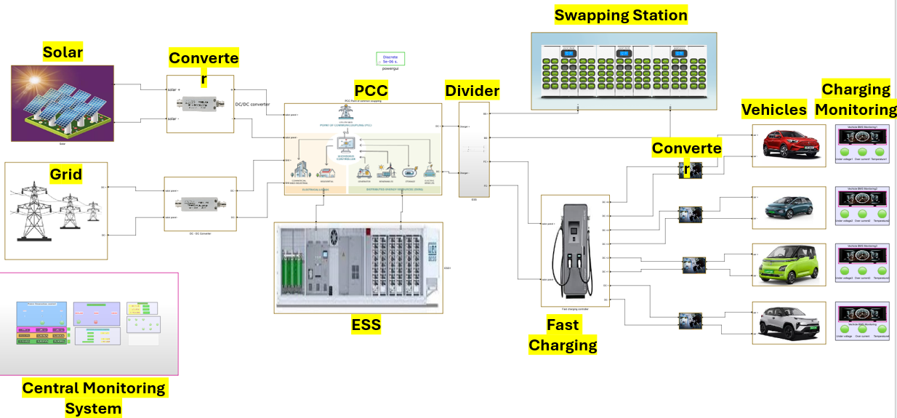
Fig 6: The Simulation of Designed Battery Charging system
The integration of these components enables the system to adapt effectively to fluctuations in energy production and consumption. Continuous monitoring of battery performance parameters—such as voltage, current, State of Charge (SOC), and temperatures facilitated through an Internet of Things (IoT) architecture. This real-time data collection supports proactive management of charging operations, ensuring optimal battery health. The proposed IoT architecture consists of five distinct layers: the User Interface Application Layer, Cloud Server and Data Storage, Communication Layer, Microcontroller Layer, and Sensor Layer. This layered approach allows for centralized monitoring and control, enabling users to easily track charging status and energy consumption.

a) Solar
Solar energy serves as a primary renewable source, providing clean and abundant power during peak sunlight hours. By incorporating solar panels into charging stations, these facilities can generate their own electricity, significantly reducing reliance on grid power and lowering operational costs. This approach not only minimizes carbon emissions associated with conventional energy generation but also enhances the overall efficiency of the charging process.

b) ESS
Energy Storage Systems (ESS) play a crucial role in this architecture by storing excess energy generated from solar panels for later use. This capability allows charging stations to maintain a reliable energy supply even when solar generation is insufficient. The integration of ESS ensures that energy is available during peak demand periods, thereby optimizing the use of renewable resources and enhancing the resilience of the charging infrastructure.

c) Grid power
Grid power acts as a backup source, ensuring that charging operations can continue uninterrupted when solar energy and stored energy from the ESS are not sufficient. The automation at the PCC facilitates seamless transitions between these power sources, allowing for dynamic management of energy flows based on real-time conditions. For instance, when solar energy is available, the system prioritizes its use; if the ESS charge exceeds a certain threshold, excess power can be sent back to the grid.
d) PCC Integration and Automation
The integration of solar energy, Energy Storage Systems (ESS), and grid power at the Point of Common Coupling (PCC) is crucial for developing an efficient and sustainable battery charging infrastructure for electric vehicles (EVs). This integration allows for dynamic management of energy flows, ensuring that charging operations can adapt to varying energy demands while promoting environmental sustainability. The simulated PCC is shown in fig 7. Solar energy serves as the primary renewable source, providing clean power that can be harnessed during peak sunlight hours. By incorporating solar panels into the charging infrastructure, stations can generate their own electricity, significantly reducing reliance on grid power and operational costs.
The ESS plays a vital role by storing excess solar energy for later use, ensuring a reliable energy supply even when solar generation is insufficient. This capability enhances the resilience of the charging infrastructure and allows for optimal utilization of renewable resources. Grid power acts as a backup source, ensuring uninterrupted charging operations when solar and stored energy are not sufficient.

Fig 7: Integrated and Automation PCC control
Automation at the PCC facilitates seamless transitions between these power sources, optimizing energy distribution based on real-time conditions. For instance, when solar energy is available, the system prioritizes its use; if the ESS charge exceeds a certain threshold, excess power can be redirected to the grid. Conversely, if solar generation is low and the ESS charge falls below a specified level, grid power is activated to maintain charging operations.
This integrated approach is supported by real-time data monitoring through an Internet of Things (IoT) architecture, which continuously tracks parameters such as voltage, current, State of Charge (SOC), and temperature. The collected data enables proactive management of charging operations and ensures optimal battery health. Additionally, predictive analytics within the IoT framework forecast energy demand and optimize charging schedules based on historical data and current usage patterns.
- Battery Swapping Station.
Battery swapping stations are essential in the evolving electric vehicle (EV) infrastructure, significantly enhancing battery management efficiency and convenience. The integration of 30 lithium-ion batteries, each rated at 12V and 10A, connected to the Point of Common Coupling (PCC), highlights their role in supporting sustainable transportation solutions. The simulation is shown in fig8. One of the key advantages of battery swapping is the rapid refueling capability it offers; drivers can replace depleted batteries with fully charged ones in minutes, drastically reducing downtime compared to traditional charging methods. This technology also alleviates range anxiety, allowing users to extend their driving range without concerns about long charging times, which is particularly beneficial for commercial fleets and ride-sharing services that require quick turnaround times.
Fig 8: Battery Swapping Station Simulation.
The centralized management of lithium-ion batteries in swapping stations improves battery health and longevity by continuously monitoring parameters such as State of Charge (SOC), temperature, and overall performance. This proactive approach ensures that only batteries in optimal condition are deployed to vehicles. Additionally, strategically locating battery swapping stations near renewable energy sources, like integrated solar power systems at the PCC, allows for efficient energy management. Excess solar energy can be stored in swapped batteries during peak generation times, promoting sustainability and reducing reliance on grid power.
- DC Fast charging station
The DC fast charging stations are a crucial element in the electric vehicle (EV) infrastructure, addressing the increasing demand for rapid and efficient charging solutions. These stations utilize direct current (DC) to deliver high power levels, significantly reducing charging times compared to traditional AC methods. One of their primary advantages is the ability to charge EV batteries to 80% in as little as 30 minutes, making them essential for users who need quick turnaround times, such as fleet operators and long-distance travelers. The simulation of DC Fast Charging station shown in fig 9. By providing fast charging options, these stations alleviate range anxiety, encouraging more consumers to adopt electric vehicles and contribute to a sustainable transportation ecosystem.
Fig 9: DC Fast Charging Station.

The proposed system integrates DC fast charging stations with renewable energy sources like solar power and Energy Storage Systems (ESS), facilitating efficient energy management. Excess solar energy can be harnessed for fast charging, promoting sustainability and reducing reliance on grid electricity. Designed to handle higher power levels, these stations are suitable for commercial applications and public charging networks, accommodating multiple vehicles simultaneously to meet high demand in urban areas and along major travel routes.

- Data Monitoring and Cloud Connectivity.
- Node-Red Connectivity and Dashboard monitoring
The integration of MATLAB with ThingSpeak and Node-RED is a key component of the proposed IoT architecture for battery charging management, enabling real-time data monitoring, analysis, and visualization. In this setup, MATLAB acts as the primary platform for collecting and processing data related to power sources and load operations at the charging station, including metrics such as voltage, current, State of Charge (SOC), and power output from solar panels, Energy Storage Systems (ESS), and grid electricity. Once this data is generated in MATLAB, it is uploaded to ThingSpeak, a cloud-based IoT analytics platform that facilitates the storage and analysis of time-series data. This aggregation allows users to visualize trends and performance metrics over time, which is essential for assessing the effectiveness of the battery charging management system.

Following the data upload to ThingSpeak, information is transmitted to Node-RED, a flow-based programming tool that allows for customization and visualization of data. Users can create dashboards in Node-RED that display real-time information on charging status and energy consumption, enhancing user engagement through intuitive access to system performance metrics. Additionally, Node-RED supports automation by triggering alerts based on predefined conditions, such as when SOC levels drop below a certain threshold or when solar energy production exceeds expectations.
Fig 10: Node-Red Simulation

The seamless flow of data from MATLAB to ThingSpeak and then to Node-RED exemplifies an effective IoT architecture that enhances operational efficiency in battery charging management. By leveraging these technologies, the system optimizes energy usage and supports proactive decision-making through real-time analytics. The Node-Red flow shown in fig 10. This integration ultimately contributes to a more sustainable transportation ecosystem by maximizing renewable energy utilization while ensuring reliable service availability for electric vehicle users.

Fig 11: Dashboard Visualization
The integration of data collected from sensors and systems into a cohesive visual format. Users can easily track the performance of charging stations, assess energy consumption patterns, and monitor the operational status of battery swapping and fast charging units. Visual dashboards enhance user engagement by providing intuitive access to critical information, enabling operators to make informed decisions quickly.
- AWS cloud Connectivity
Amazon Web Services (AWS) plays a vital role in enhancing functionality and reliability through data storage, notification management, and visualization. Data Storage in Amazon S3 utilizes Amazon Simple Storage Service (S3) to securely store extensive data generated by the system, including metrics related to solar energy production, Energy Storage System (ESS) performance, grid power usage, and battery swapping operations. S3 offers a scalable and durable solution for efficient data management, facilitating easy retrieval and analysis of historical data to gain insights into system performance over time.
To improve operational efficiency, the system employs Amazon Simple Notification Service (SNS) for email alerts based on predefined conditions. For example, if the State of Charge (SOC) of the ESS falls below a certain threshold or if anomalies are detected in energy production or consumption, SNS can automatically trigger notifications to stakeholders. This ensures timely interventions to maintain optimal system performance.


Fig 11. AWS Flow
It provides powerful visualization capabilities through Amazon QuickSight, enabling users to create interactive dashboards from the data stored in S3. By integrating QuickSight into the battery charging management system, stakeholders can visualize key performance indicators (KPIs) such as energy production trends and charging efficiency metrics. Custom dashboards display real-time analytics, allowing users to monitor system performance effectively and make informed decisions based on visualized data.
- Results Energy and Cost Efficiency
The project results indicate significant energy and cost efficiency achieved through the integration of solar energy, Energy Storage Systems (ESS), and grid power in the battery charging management system. Daily power generation is distributed as follows: 60% from solar energy, 40% from ESS, and 10% from the grid, leading to an impressive overall energy efficiency of 88.5%.

Fig 12. Energy estimation graph

In terms of cost, the system charges customers 10 rupees per unit for fast charging and 50 rupees per battery swap. The utilization of grid power incurs a cost of 12 rupees per unit on the energy bill. Notably, the project has demonstrated a year-on-year profit increase of 40-60%, showcasing the economic viability of this integrated approach to EV charging infrastructure. This combination of renewable energy sources and efficient operational practices not only enhances sustainability but also contributes to a profitable business model in the rapidly growing electric vehicle market.

Fig 12. Cost estimation Graph

- Conclusion

This IoT architecture for battery charging management not only meets the immediate challenges posed by the growing demand for EV infrastructure but also promotes sustainable practices through effective utilization of renewable energy sources. Future developments will focus on refining this architecture and expanding its capabilities to further enhance energy management in electric vehicle applications. By leveraging real-time data analytics and centralized monitoring, this project positions itself as a forward-thinking solution in the rapidly evolving landscape of electric vehicle infrastructure, ultimately contributing to a greener transportation ecosystem.

XI. Reference
- Cheng-Ta Chiang; Liang-Yu Chien “A Pitaya Dye-Sensitized Solar Cell Monitor for Environmental Sunlight Intensity Detection” IEEE Sensors Journal, 19-11, 03 February 2019.
- Saswat Kumar Ram; Sauvagya Ranjan Sahoo; Banee Bandana Das; Kamalakanta Mahapatra; Saraju P. Mohanty
“Eternal-Thing: A Secure Aging-Aware Solar-Energy Harvester Thing for Sustainable IoT” IEEE Transactions on Sustainable Computing, 6-2, 15 April 2020.
- Tai-Yeon Ku; Wan-Ki Park; Hoon Choi “ESS Simulation based on PV Generation Prediction” 2018 International Conference on Information and Communication Technology Convergence (ICTC), 18 November 2018.
- Abdelrahman Ahmed; Sobhy Abdelkader; Ehab Ayman “IoT-based optimization of microgrid operation” 2023 24th International Middle East Power System Conference (MEPCON), 18 March 2024.
- George Y. Odongo; Richard Musabe; Damien Hanyurwimfura; Abubakar Diwani Bakari “An Efficient LoRa-Enabled Smart Fault Detection and Monitoring Platform for the Power Distribution System Using Self-Powered IoT Devices” IEEE Access (Volume: 10), 07 July 2022.
- Isa Hafidz; Ardyono Priyadi; Margo Pujiantara; Dimas Okky Anggriawan; Mauridhi Hery Purnomo “Development of IoT-Based Portable Power Quality Monitoring on Microgrids by Enhancing Protection Features” IEEE Access (Volume: 11), 15 May 2023.
- Dan Zheng; Fushuan Wen; Jiansheng Huang “Optimal planning of battery swap stations” International Conference on Sustainable Power Generation and Supply (SUPERGEN 2012), 04 April 2013.
- Bansilal Bairwa; Mrinal Sarvagya; Sanjeeva Kumar; Arpita Banik “Battery Swapping Mobile Service Station for Electric Vehicles Application” 2021 Second International Conference on Smart Technologies in Computing, Electrical and Electronics (ICSTCEE), 15 February 2022.
- Xian Zhang; Guibin Wang “Optimal dispatch of electric vehicle batteries between battery swapping stations and charging stations” 2016 IEEE Power and Energy Society General Meeting (PESGM), 14 November 2016.
- Sayantika Sikdar; Madhavi Damle “IoT Solutions for Electric Vehicles (EV) Charging Stations: A Driving Force Towards EV Mass Adoption” 2022 International Interdisciplinary Humanitarian Conference for Sustainability (IIHC), 17 March 2023.
- Ashutosh Vijay Panchbhai; Ramakrishnan Raman; Chintan Bhupeshbhai Thacker; S. Muthumarilakshmi; S. Murugan “Residential Electric Vehicle Charging Station Using the Internet of Things” 2023 International Conference on Power Energy, Environment & Intelligent Control (PEEIC), 13 March 2024.
- S. Arulmozhi; M. Abiramavalli; M.B.Diviya Bhavaani; S. Loganayagi “IoT enabled E-Vehicle Charging System with Battery Monitoring and Charge Scheduling” 2023 First International Conference on Cyber Physical Systems, Power Electronics and Electric Vehicles (ICPEEV), 19 January 2024.
- Joe-Air Jiang; Jen-Cheng Wang; Hung-Shuo Wu; Chien-Hsing Lee; Cheng-Ying Chou; Li-Cheng Wu “A Novel Sensor Placement Strategy for an IoT-Based Power Grid Monitoring System” IEEE Internet of Things Journal, 7-8, 30 April 2020.
- Enrique A. Sanabria-Torres; Adriana C. Luna; Nelson L. Diaz; Fabio Andrade-Rengifo “State-of-Charge Equalizations Comparison in a Multi-prosumer Environment Based on Real-Time Energy Management Systems with IoT-Support” 2023 IEEE Applied Power Electronics Conference and Exposition (APEC), 31 May 2023.
- Santosh Kumar Tripathi; Swati Maurya; Aditi Dubey; Prakhar Pal; Aparna Tiwari “IoT Based Electrical Vehicle Battery Management System with Charge Monitor and Fire Protection” 2024 3rd International conference on Power Electronics and IoT Applications in Renewable Energy and its Control (PARC), 04 April 2024.
- Mersin, Türkiye “An IoT -based Power Management System for EV Chargers” 6th Advanced Engineering Days (AED), 5 March 2023.

